Technology Stage 4 Remote Learning at Home
Term 3 2021
- Media and Food Advertising
Aim: To examine the type and number of television food advertisements that
persuade or influence consumers to buy a product.

Method:
- Watch television during ‘prime time’ (usually 6–8 pm). It may be wise to record this period as you could have trouble noting all the advertisements as they are broadcast.
- Select six different food advertisements from the ones which appeared during your viewing time. Use these six advertisements to complete the table below (record each product only once).
- After viewing, complete the questions.

Product advertised | Time | Image portrayed/technique used | Target market

1.

2.

3.

4.

5.

6.

- Complete the questions on Media and Food Advertising

1. What is your overall impression of the media’s influence on the sale of foods?

____________________________________________________________________________________________________________________________________________________________________________________________________________________________________________________________________________________________________________________________________________________________________________________________________________________________________________________________________________________________________________________________________________________________________________________________________________________________________________________________________________________________________________

2. What is your opinion of the body images and lifestyles portrayed in these advertisements?
__________________________________________________________________________________________________________________________________________________________________________________________________________________________________________________________________________________________________________________________________________________________________________________________________________________________________________________________________________________________________________

3. Which advertising technique do you consider to be the most successful?
_____________________________________________________________________________________________________________________________________________________________________________________________________________________________________________________________________________________________________________________________________________________________________________

Food Selection

Australians should eat more fruits and vegetables.

Name a fruit or vegetable that starts with each letter of the alphabet. Find at least 20 names.

A ____________________________________________________________________________________

B ____________________________________________________________________________________

C ____________________________________________________________________________________

D ____________________________________________________________________________________

E ____________________________________________________________________________________

F ____________________________________________________________________________________

G ____________________________________________________________________________________

H ____________________________________________________________________________________

I _____________________________________________________________________________________

J _____________________________________________________________________________________

K ____________________________________________________________________________________

L ____________________________________________________________________________________

M ____________________________________________________________________________________

N ____________________________________________________________________________________

O ____________________________________________________________________________________

P _____________________________________________________________________________________

Q ____________________________________________________________________________________

R _____________________________________________________________________________________

S _____________________________________________________________________________________

T _____________________________________________________________________________________

U _____________________________________________________________________________________

V _____________________________________________________________________________________

W _____________________________________________________________________________________

X ______________________________________________________________________________________

Y ______________________________________________________________________________________

Z _______________________________________________________________________________________

BANANAS!!!!!!

Write a short story titled  “a day in the life of a banana”. | Write a speech on ’10 reasons to eat bananas’. | Create a collage on different types and varieties of bananas grown in the world.
List all the nutritional values and benefits of eating bananas  (must be at least 5). | Find out how many people in your family love or hate bananas and give a reason for their choices. | Create a collage with images and names of 10 dishes that could be made using bananas.
Find a picture of a banana tree and label as many parts as possible. | Create a comic strip using a banana as the main star. | Write a review of a dish you have cooked using bananas as an ingredient  (Must be at least 75 words).
Create a rap about bananas. | Show on a map of Australia where all bananas are grown. | Explain how Australia’s bananas are grown and explain the process that takes place to get them to your house.

Responsible and safe use of a range of tools, materials, and techniques: Technology (Mandatory)
In Technology you will learn about responsible and safe use of a range of tools, materials, and techniques in design projects.

Activity: Responsible and safe use of a range of tools, materials and techniques
Insert the most appropriate word from the boxes below and insert it into each sentence so the sentence reads as a true statement.

bench centre | blunt tools | brochures | power
chisel | damage | directed | dust mask
earthed | extension lead | 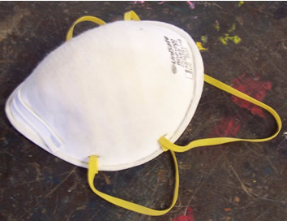
injury | moving parts
power cable | pressure
shoes | switches
canvas | timber
sharp | racked
person | particles
guards

- Tools in use should be kept in the __________ __________ away from other equipment and, when not in use, should be ___________________.
- For best results in the workshop, all tools should be _____________ and used as __________.
- _______________ about new materials or tools should be studied as it will save time, avoid mistakes and help produce quality work.
- ____________ or open _________ are not good enough protection against a dropped _______ or heavy piece of _____________.
- A ___________ ______________ should be worn to protect against irritation caused by fine dust _______________.
- _______________ _____________ require greater _______________ than sharp ones and so are more likely to cause ______________ to the user or __________________ to the work.
- The flexible ____________ ____________ to all portable power tools must be properly ___________________.

- Switch off the _______________ before fitting any ______________ ___________.
- Fixed power machines must, always, have _________________ properly fitted over any _________________ _________________.
- Only the _____________ using any machine should operate the ______________________

The safe use of hand tools: Technology (Mandatory)
In Technology you will learn about the correct and safe use of tools and materials for specific processes that are used to construct a project.

The safe use of hand tools
Carefully read the following passage about the use of hand tools in the workshop and complete the questions.

- When undertaking a project in the workshop, never use any hand tool unless you have had instruction from your teacher and are familiar with the correct use of a tool. If you have a question about the use of a hand tool, ask your teacher.
- Hands should be kept behind the cutting edge of sharp tools such as chisels and gouges when removing waste material. | 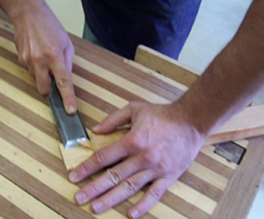  This photo shows an unsafe practice.
- Inspect tools before each use and repair or replace if worn or damaged. Keep cutting edges sharp. Never test a cutting edge with your fingers. Test the operation of the tool on a scrap piece of material.

- Hold material securely on the bench with a bench hook, G-cramp or vice when working on it. Use light slow strokes when commencing a saw cut and ease the pressure as the saw breaks through the material being cut. |  | 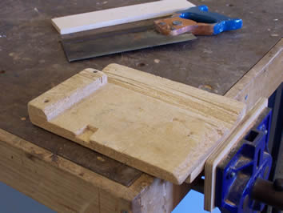  A bench hook.
- Use light slow strokes when commencing a saw cut and ease the pressure as the saw breaks through the material being cut.  - Ensure that material is never allowed to protrude past the edge of the bench. |  | 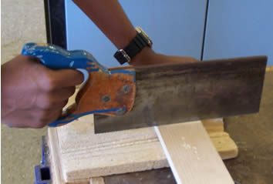  Using a bench hook for sawing.
- When carrying sharp tools, point cutting edges away from you. Never put sharp or pointed tools in your pockets.  - Where appropriate, wear personal protective equipment (PPE) such as safety glasses, safety goggles, ear protection and hair restraint. | 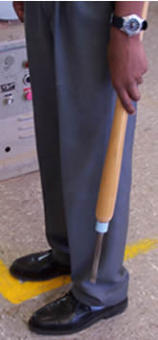  A safe method to carry sharp tools.

Activity: Hand tool guidelines

Complete the following sentences by inserting appropriate wording:

- Never use any hand tool unless you are familiar with its use and have had relevant __________.
- If you have a question about how to use a hand tool, _____________ your teacher.
- Inspect tools before each use and _________ or replace if worn or damaged. Keep cutting edges _______.
- Never test a cutting _______ with your fingers. Test the operation of the tool on a _______ piece of material.
- Hold _________ securely on the bench with a bench hook, G-cramp or vice when working on it.
- Use light slow strokes when commencing a saw _____ and ease the __________ as the saw breaks through the material being cut.
- Ensure that __________ is never allowed to protrude past the edge of the bench.
- Keep hands behind the ________ edge of sharp tools such as chisels and gouges when removing waste material.
- When carrying sharp tools, point cutting _______ away from you. Never put sharp or pointed ________ in your pockets
- Wear personal protective equipment (PPE) such as safety _______, safety goggles, ear protection and hair restraint where appropriate in the workshop.

The safe use of machines: Technology (Mandatory)
In Technology you will learn about the correct and safe use of tools and materials for specific processes that are used to construct a project.

This material addresses aspects of the following syllabus outcome:
LS 3.4 A student demonstrates safe practices in the use of materials, tools, and equipment in the context of producing a design project.
Extract from: Stage 4 Technology Syllabus © Board of Studies NSW 2003.

Activity: The safe use of machines
Use the words from the word bank to complete the following passage:

distance | safety guards | instruction | protection | distracted
cleared | machine | unattended | teacher | switched off

- Don’t operate a __________unless you have received thorough __________ and fully understand how the machine should be used. When using machinery that is fitted with __________ ___________ , ensure that they are fitted correctly. When appropriate wear eye and ear _____________ and restrain hair.
- Keep a safe ___________ between your hands and any moving parts of the machinery, and only make adjustments to the machinery when the power is ____________ _____ . Ensure that you operate a machine by yourself, and do not leave a machine ____________ while it is running. Give your machine your full attention and do not look away or talk to others while using a machine. Operators of machinery should not be __________.
- Never lean on machines. If any part of the machine is broken or malfunctions notify your _________ immediately. After using machines, the work area should be _________ of scrap material and machine accessories. | 